Programming Fundamentals
Leet Code Assignment
Rana Muhammad Hussain
25K-0141
1.Running sum of 1d Array:
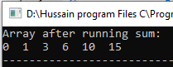
2.Transform Array by Parity:
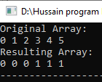
3.Array Shuffling Program:
